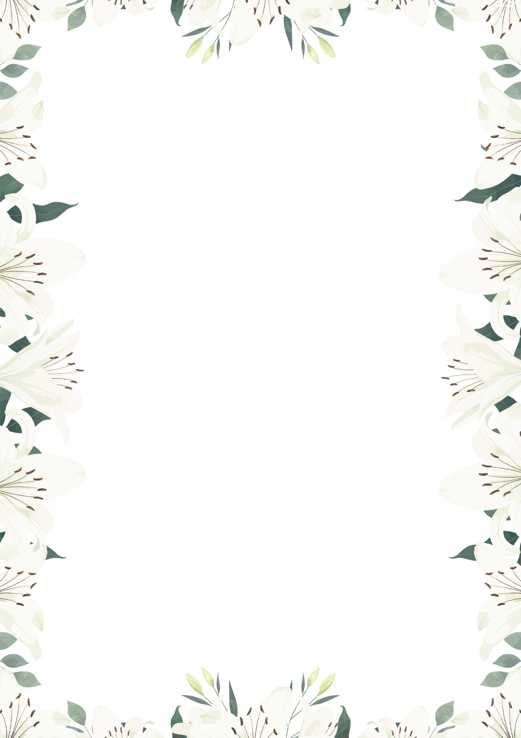
The Wedding Ceremony

Procession
- Seating of the Mothers — “Canon in D” (Pachelbel)
- Procession of the Maid of Honor and Bridesmaids — “Canon in D” (Pachelbel)
- Procession of the Bride — *“Hornpipe” from Water Music (Handel)

Liturgy of the Word
- Welcome & Opening Prayer
- First Reading: Proverbs 31:10–13, 19–20, 30–31 — read by Holly Guzman
- Responsorial Psalm: Psalm 145:8–9, 15–18
- Second Reading: Hebrews 13:1–4a, 5–6b — read by Jennifer Post
- Gospel Acclamation: 1 John 4:16
- Gospel: John 15:9–12

Rite of Marriage
- Exchange of Wedding Vows
- Blessing & Exchange of the Rings
- Sand Ceremony — “And on This Day”

Liturgy of the Eucharist
- Prayer of the Faithful
- Presentation of the Gifts — “Ave Maria”
Presented by Matthew & Judy Machniak and Gary & Karin Eckert
- The Lord’s Prayer
- Nuptial Blessing
- Sign of Peace
- Communion

Concluding Rites
- Final Blessing
- Recessional — “Ode to Joy” (Beethoven)

