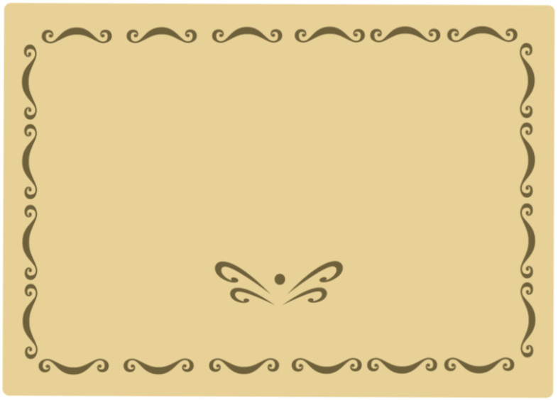Dear _______________,

Thank you so much for the thoughtful birthday card and gift of money. I really appreciate your thoughtfulness. I also loved the sprinkles of confetti that fell onto my lap when opening my birthday card. It made me laugh and smile, and made my special day even brighter. I love and miss you so much. I think about you all the time and send good wishes your way. Thank you again for the birthday cash. When it comes to wonderful aunts, you really are the best!

Hugs and kisses,

(YOUR NAME HERE)