


If you are a Heart Type: use your journal to think about and write down people or things outside of yourself that you are grateful for each day.

If you are a Lung Type: use your journal to think about and write down aspects of yourself and things that you do that you are grateful for each day.

- Plan to write in your gratitude journal every evening.

Just before going to sleep can be a good time for some people. Give yourself at least 10-15 minutes space to do this. You might want to set an alarm reminder on your phone or schedule it in your calendar to remind you if you find this difficult.

- Keep your gratitude journal by your bed so you will see it before

going to sleep and remember to jot down what you are thankful for. Your journal may even become a symbol of gratitude so that when you just look at it, you will feel a sense of appreciation.

- You can write as many things as you like in your gratitude journal
but aim to start with 3-5.

- Your gratitude journal doesn’t have to be deep.

What you are thankful for can be simple. For example, heart types may consider things such as “family” or “the new book or movie I recently enjoyed” while lung types note things such as: “I stated my preference for eating this evening” or “I have the ability to walk to and from work” or “I took 10 minutes just for myself today”. What you are grateful for will differ from everyone else.

Use the Heart type or Lung type week template below. You can copy this and use it for as long as you want.



Today I am grateful for…

1.

2.

3.


Today I am grateful for…


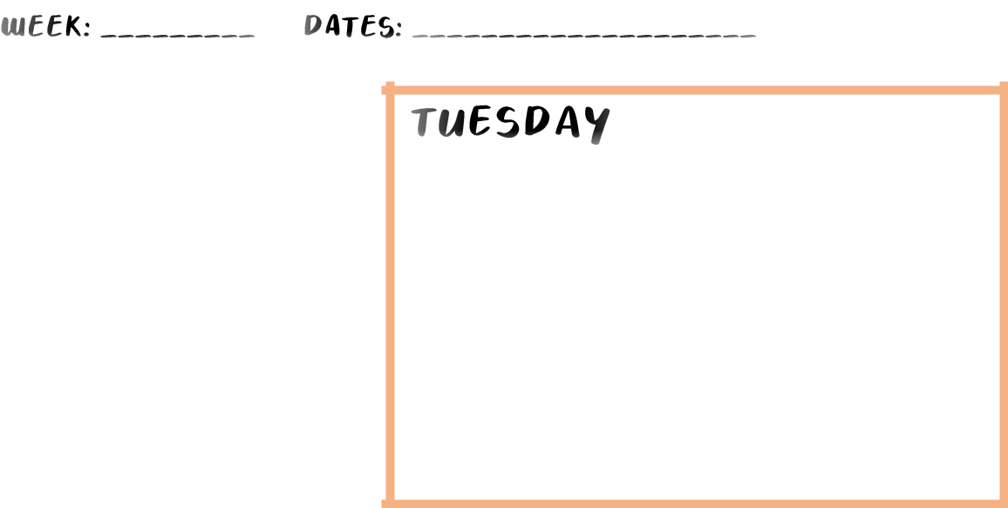

1.

2.

3.


Today I am grateful for…

1.

2.

3.


Today I am grateful for…

1.

2.

3.

Today I am grateful for…

1.

2.

3.


Today I am grateful for…

1.

2.

3.


Today I am grateful for…

1.

2.

3.

