SPECIALTY MENU
Menu Item Name | 00
Menu Description

Menu Item Name | 00
Menu Description

Menu Item Name | 00
Menu Description

Menu Item Name | 00
Menu Description

Menu Item Name | 00
Menu Description

Menu Item Name | 00
Menu Description

Menu Item Name | 00
Menu Description

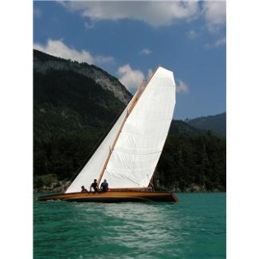
Menu Item Name | 00
Menu Description

Menu Item Name | 00
Menu Description

Menu Item Name | 00
Menu Description

