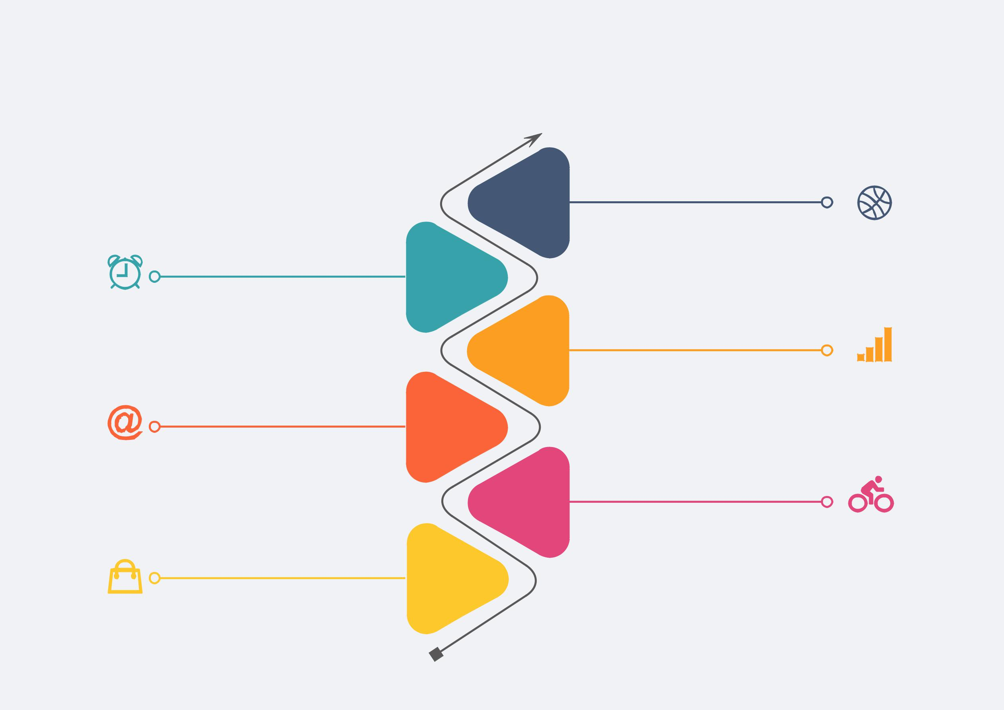**Vertical Timeline Template**

**Your title**

Use the float button to

change the basic setting of

circular chart.

**Your title**

Use the float button to

change the basic setting of

circular chart.

**Your title**

2020

2019

2018

2017

2016

**Your title**

Use the float button to

change the basic setting of

circular chart.

**Your title**

Use the float button to

change the basic setting of

circular chart.

**Your title**

Use the float button to

change the basic setting of

circular chart.

|  |  |
| --- | --- |
| Use the float button to |  |
| change the basic setting of |  |
| circular chart. | 2015 |
|  |