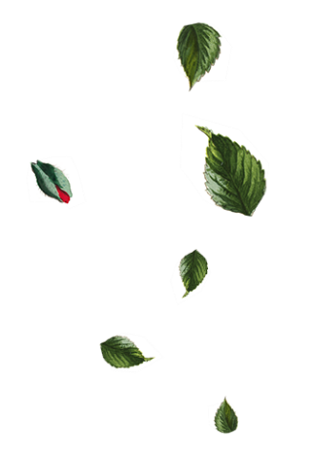

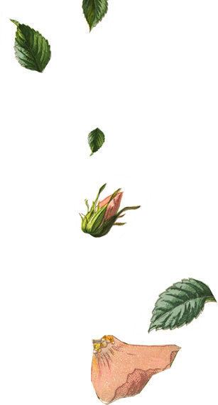
 | - You are invited to join

Flora Persson

Kalle Astrom
 | Flora Persson  Kalle Astrom | &
 | on our wedding day
 | - You are invited to join

Flora Persson

Kalle Astrom
 | Flora Persson  Kalle Astrom | &
 | on our wedding day

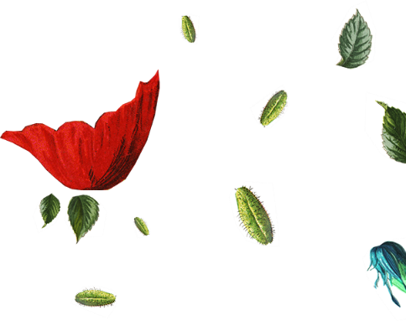
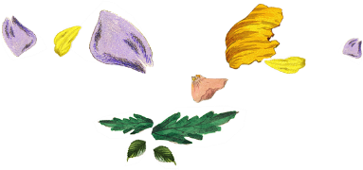
Mr. & Mrs. Partner’s Parents
Request the honor of Your Presence
At the marriage of

Partner’s Name
To

Partner’s Name
Child of
Mr. & Mrs. Partner’s Parents

Saturday the Twenty-First of June

Two thousand and [Year]

Eleven O’clock in the morning

At Location City, State.

Reception to Follow
Mr. & Mrs. Partner’s Parents
Request the honor of Your Presence
At the marriage of

Partner’s Name
To

Partner’s Name
Child of
Mr. & Mrs. Partner’s Parents

Saturday the Twenty-First of June

Two thousand and [Year]

Eleven O’clock in the morning

At Location City, State.

Reception to Follow

